**Industrial Internship Report on**

**” Prediction of Agriculture Crop Production in India”**

**Prepared by**

**Muhammed Unais P**

|  |
| --- |
| *Executive Summary* |
| This report provides details of the Industrial Internship provided by upskill Campus and The IoT Academy in collaboration with Industrial Partner UniConverge Technologies Pvt Ltd (UCT).  This internship was focused on a project/problem statement provided by UCT. We had to finish the project including the report in 6 weeks’ time.  My project was **Prediction of Agriculture Crop Production in India** in which i have used regression, decision tree and random forest algorithms to predict the production of crop in india and I’ve compared accuracies of algorithms .The data contains 7 columns and 246091 rows and among all algorithms decision tree algorithm gave me good accuracy.  This internship gave me a very good opportunity to get exposure to Industrial problems and design/implement solution for that. It was an overall great experience to have this internship. |

**TABLE OF CONTENTS**

1 Preface 3

2 Introduction 4

2.1 About UniConverge Technologies Pvt Ltd 4

2.2 About upskill Campus 8

2.3 Objective 9

2.4 Reference 9

2.5 Glossary 10

3 Problem Statement 11

4 Existing and Proposed solution 12

5 Proposed Design/ Model 13

6 Performance Test 14

6.1 Test Plan/ Test Cases 14

6.2 Test Procedure 14

6.3 Performance Outcome 14

7 My learnings 15

8 Future work scope 16

# Preface

Summary of the whole 6 weeks’ work.

About need of relevant Internship in career development.

Brief about Your project/problem statement.

Opportunity given by USC/UCT.

How Program was planned

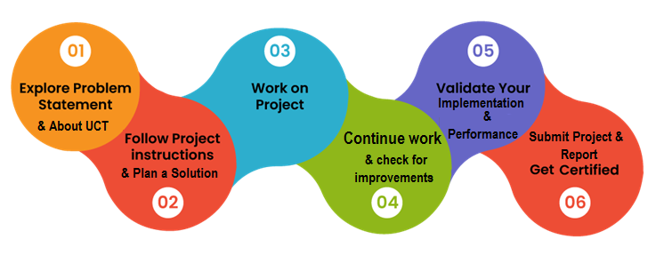

Your Learnings and overall experience.

Thank to all (Kaushalendra singh shisodia sir), who have helped you directly or indirectly.

Your message to your juniors and peers.

# Introduction

## About UniConverge Technologies Pvt Ltd

A company established in 2013 and working in Digital Transformation domain and providing Industrial solutions with prime focus on sustainability and RoI.

For developing its products and solutions it is leveraging various**Cutting Edge Technologies e.g. Internet of Things (IoT), Cyber Security, Cloud computing (AWS, Azure), Machine Learning, Communication Technologies (4G/5G/LoRaWAN), Java Full Stack, Python, Front end**etc.

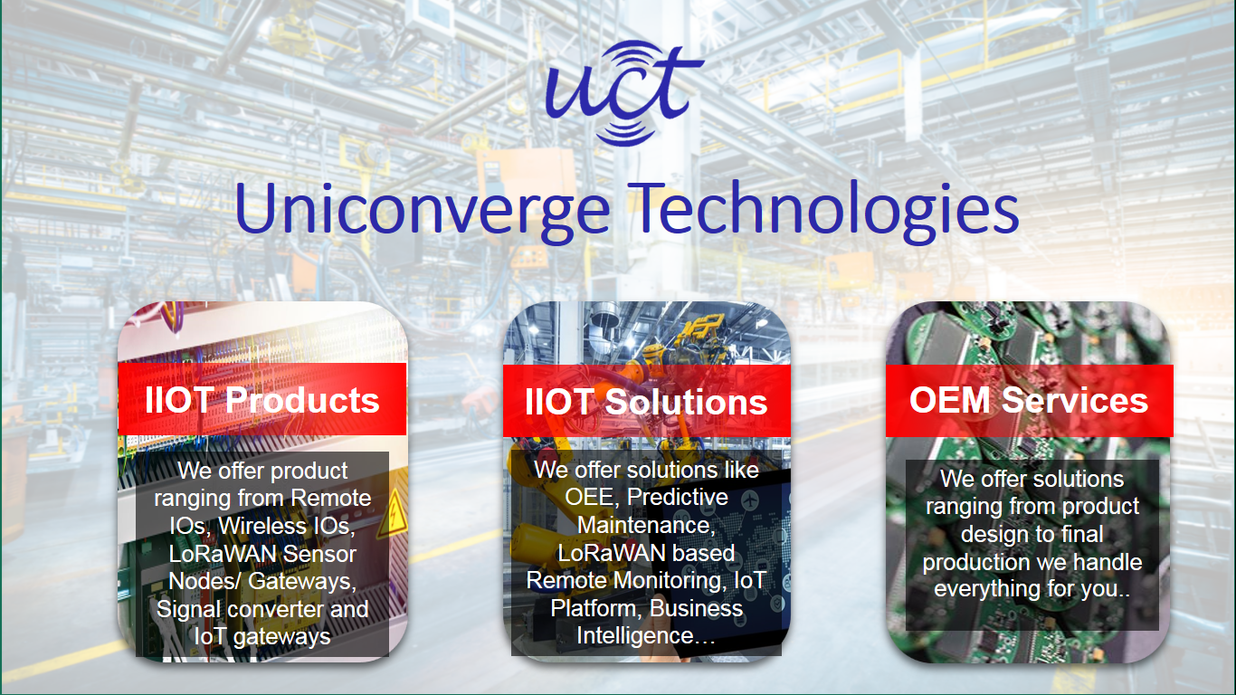

1. UCT IoT Platform **(****)**

**UCT Insight** is an IOT platform designed for quick deployment of IOT applications on the same time providing valuable “insight” for your process/business. It has been built in Java for backend and ReactJS for Front end. It has support for MySQL and various NoSql Databases.

* It enables device connectivity via industry standard IoT protocols - MQTT, CoAP, HTTP, Modbus TCP, OPC UA
* It supports both cloud and on-premises deployments.

It has features to  
• Build Your own dashboard  
• Analytics and Reporting  
• Alert and Notification  
• Integration with third party application(Power BI, SAP, ERP)  
• Rule Engine

 

1. **Smart Factory Platform (****)**

Factory watch is a platform for smart factory needs.

It provides Users/ Factory

* with a scalable solution for their Production and asset monitoring
* OEE and predictive maintenance solution scaling up to digital twin for your assets.
* to unleased the true potential of the data that their machines are generating and helps to identify the KPIs and also improve them.
* A modular architecture that allows users to choose the service that they what to start and then can scale to more complex solutions as per their demands.

Its unique SaaS model helps users to save time, cost and money.

 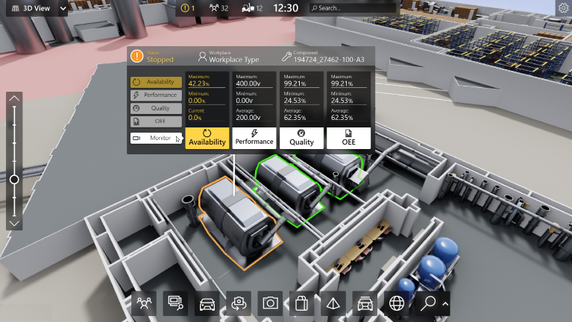

1.  based Solution

UCT is one of the early adopters of LoRAWAN teschnology and providing solution in Agritech, Smart cities, Industrial Monitoring, Smart Street Light, Smart Water/ Gas/ Electricity metering solutions etc.

1. Predictive Maintenance

UCT is providing Industrial Machine health monitoring and Predictive maintenance solution leveraging Embedded system, Industrial IoT and Machine Learning Technologies by finding Remaining useful life time of various Machines used in production process.



## About upskill Campus (USC)

upskill Campus along with The IoT Academy and in association with Uniconverge technologies has facilitated the smooth execution of the complete internship process.

USC is a career development platform that delivers **personalized executive coaching** in a more affordable, scalable and measurable way.



Seeing need of upskilling in self paced manner along-with additional support services e.g. Internship, projects, interaction with Industry experts, Career growth Services

<https://www.upskillcampus.com/>

upSkill Campus aiming to upskill 1 million learners in next 5 year

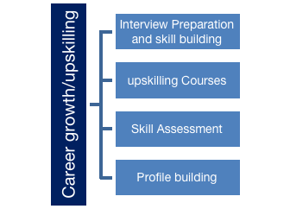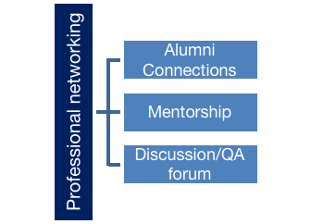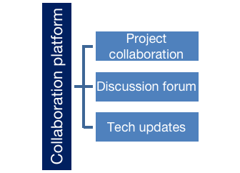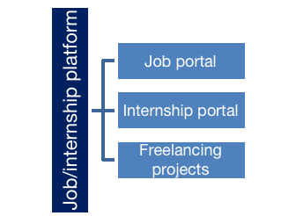

## 

## 2.3 The IoT Academy

The IoT academy is EdTech Division of UCT that is running long executive certification programs in collaboration with EICT Academy, IITK, IITR and IITG in multiple domains.

## Objectives of this Internship program

The objective for this internship program was to

 ☛ get practical experience of working in the industry.

 ☛ to solve real world problems.

 ☛ to have improved job prospects.

 ☛ to have Improved understanding of our field and its applications.

 ☛ to have Personal growth like better communication and problem solving.

## Reference

[1] https://www.kaggle.com/datasets

[2] interviewbit.com

[3] https://www.geeksforgeeks.org/machine-learning-projects/

## Glossary

|  |  |
| --- | --- |
| Terms | Acronym |
| SVM | Support vector machine |
| sklearn | Scikit learn |
| DT | Decision tree |

# Problem Statement

In the assigned problem statement

India, being predominantly an agrarian economy, heavily relies on agriculture for food security and economic growth. However, the country faces significant challenges in ensuring agricultural productivity, given the diverse agro-climatic conditions, limited natural resources, and the unpredictable impact of climate change. The need of the hour is to develop an accurate and robust Crop Prediction Model that can aid farmers, policymakers, and other stakeholders in making informed decisions to achieve sustainable agriculture and food security.

The objective of this project is to design and implement a Crop Prediction Model for India, which addresses the following key challenges:

**Accurate Crop Yield Forecasting**: The model must accurately predict crop yields for major crops grown in different regions of India. Accurate yield predictions can help farmers plan their farming practices, optimize resource allocation, and estimate potential revenues.

**Climate Resilience**: With climate change posing new challenges in terms of erratic weather patterns, extreme events, and changing agro-climatic conditions, the model should factor in climate variables to improve the accuracy of crop predictions and provide insights into climate-resilient farming practices.

**Crop Recommendations**: The model should go beyond yield predictions and suggest suitable crop choices based on historical data, soil health, and prevailing climatic conditions. Recommending crops that are well-suited to specific regions can enhance agricultural productivity and reduce the risk of crop failure.

**Data Accessibility and Integration**: India's agricultural landscape is vast and diverse. The model should be built to integrate and analyze data from various sources, including satellite imagery, weather stations, soil quality assessments, historical crop data, and other relevant datasets, ensuring the availability of accurate and up-to-date information.

**Privacy and Security**: Handling sensitive agricultural and climatic data requires robust privacy and security measures to safeguard farmers' and stakeholders' information from unauthorized access and breaches.

Overall, the successful development and implementation of the Crop Prediction Model can empower farmers with knowledge, reduce resource wastage, enhance agricultural productivity, and contribute to sustainable food production for India's growing population.

# Existing and Proposed solution

**Existing Solution for Crop Prediction Model**:

Currently, crop prediction models in India mainly rely on statistical and data-driven approaches, historical crop data, and weather-based algorithms. Some of the existing solutions include:

**Statistical Models**: Traditional statistical methods like linear regression, time series analysis, and machine learning algorithms are used to analyze historical crop data and predict future yields. These models may consider factors like rainfall, temperature, soil quality, and historical crop performance to make predictions.

Remote Sensing and GIS: Satellite imagery and geographical information systems (GIS) are used to monitor crop health, vegetation indices, and land use patterns. These technologies can provide valuable insights into crop conditions and support crop yield estimations.

**Weather-Based Models**: Weather-based models use weather data from meteorological stations to predict crop yields. They analyze the correlation between weather variables and crop performance to forecast yields for specific regions.

Proposed Solution for Crop Prediction Model:

To improve the accuracy and effectiveness of crop prediction in India, a more holistic and data-driven approach can be adopted. The proposed solution integrates existing methodologies and introduces new elements:

**Machine Learning and AI Techniques**: Utilize advanced machine learning algorithms, such as ensemble methods, neural networks, and deep learning, to process vast amounts of data and identify intricate patterns that impact crop performance. These models can consider a wide range of factors, including climate data, soil health, pest and disease incidence, crop management practices, and socio-economic variables.

**Big Data Integration**: Integrate and analyze data from diverse sources, including satellite imagery, weather stations, soil health assessments, agricultural databases, and government records. This will enable a comprehensive analysis and a more accurate prediction of crop performance.

**Climate Change Adaptability**: Develop a climate-resilient model that considers the potential impact of climate change on crop yields. This includes modeling the effects of rising temperatures, changing rainfall patterns, and extreme weather events to assess crop vulnerability and suggest adaptive measures.

By combining these proposed solutions, the Crop Prediction Model can revolutionize agricultural practices in India, leading to better resource management, increased productivity, and sustainable food security for the nation.

## Code submission (Github link)

<https://github.com/Unais2003/upskill_campus/blob/main/Crop%20prediction%20model%20.ipynb>

## Report submission (Github link) :

## 

## 4.3 Proposed Design/ Model

My project crop prediction model has following steps:

1. Import required libraries.
2. Reading the required Dataset.
3. Data Preprocessing.
4. Exploraotory Data Analysis (EDA).
5. Fitting data to regression model.
6. Fitting data to Decision tree model.
7. Fitting data to random forest model.
8. Compare the accuracies of models.
9. Conclusion

# Performance Test

The results of the performance test on crop prediction model are :

## Test Plan/ Test Cases

The collected data contains the attributes like state name, Distrct name, Crop year, Season, crop, Area and production.

The shape of dataset is   
(246091, 7).

Which indicates that data ha 2,46,091 rows along with 7 columns.

By having more test cases we can get good accuracy of model but in case if we have less number of rows then we get less accuracy of the model due to presence of outliers in the model.

## Test Procedure

The test procedure contains the following steps:

1. divide the data set into train and test.
2. Now start fitting the training data to regression model.
3. Now fit test data to model and evaluate the performance of the model.
4. In the same way evaluate the performance of the Decision tree and random forest algorithms.
5. Note down the obtained results.

## Performance Outcome

The performance outcomes are:

1. The Linear Regression R2 score : -66175.59283970056
2. The Random Forest R2 score : 0.9473978231931719
3. The Decision Tree R2 score : 0.9585143413328677
4. Accuracy : 90.47%
5. Standard Deviation : 6.36%

# My learnings

A crop prediction model can provide valuable insights and benefits to various stakeholders in the agricultural sector. Here are some key learnings that can be derived from a well-developed crop prediction model:

**Optimal Resource Allocation**: Farmers can make informed decisions about the optimal allocation of resources such as water, fertilizers, pesticides, and labor based on the predicted crop yields. This helps in reducing resource wastage and improving overall efficiency in agricultural practices.

**Improved Crop Planning**: With accurate crop yield predictions, farmers can plan their planting and harvesting schedules better. They can choose the right crops for specific regions and seasons, leading to higher productivity and reduced risk of crop failure.

**Climate-Resilient Farming:** By incorporating climate data and predictions into the model, farmers can adapt their farming practices to be more climate-resilient. They can choose crop varieties and agricultural techniques that are better suited to changing weather patterns and minimize the impact of extreme events**.**

**Crop Diversification**: The model's crop suitability recommendations can encourage farmers to diversify their crop choices. This not only enhances food security but also reduces the reliance on a single crop, which can be vulnerable to disease outbreaks or market fluctuations.

**Early Warning for Crop Failure**: The model can provide early warning signs of potential crop failures or yield fluctuations. This allows farmers to take proactive measures, such as implementing pest control strategies or adjusting irrigation, to mitigate losses.

# Future work scope

The future work scope of a crop prediction model encompasses various aspects that can further enhance its accuracy, usability, and impact on the agricultural sector. Some key areas for future development and improvement include:

**Integration of New Data Sources**: Explore and incorporate additional data sources, such as drone imagery, IoT devices, and crowd-sourced data from farmers. These new sources can provide real-time data at a more localized level, leading to more precise predictions and personalized recommendations.

**Advanced Machine Learning Techniques**: Investigate and implement state-of-the-art machine learning techniques, including advanced deep learning models, reinforcement learning, and transfer learning. These methods can capture more complex patterns in the data, improving the model's predictive capabilities.

**High-Resolution Climate Data**: Access and utilize high-resolution climate data to better assess the impact of microclimates on crop yields. Fine-grained climate data can help farmers make more informed decisions based on hyper-localized weather conditions.

**Ensemble and Hybrid Models**: Combine multiple models and prediction algorithms through ensemble techniques or hybrid approaches. This can leverage the strengths of different models to increase overall prediction accuracy and reduce uncertainties.

**Climate Change Adaptation Strategies**: Develop and incorporate climate change adaptation strategies into the model to help farmers prepare for changing climate patterns and ensure the sustainability of agricultural practices in the long term.

**Incorporation of Market Data**: Integrate market data, including commodity prices and demand forecasts, into the model. This can help farmers make more economically viable decisions regarding crop selection and production levels.

By focusing on these areas and continually updating the crop prediction model with new data and advancements in technology, the agricultural sector can benefit from more accurate and actionable predictions, leading to increased productivity, improved resource management, and sustainable agricultural practices for the future.